Create IBM Cloud Account

|  |  |
| --- | --- |
| Date | 02 November 2022 |
| Team ID | PNT2022TMID43320 |
| Project Name | Personal Expense Tracker Application |

**Step 1: Create IBM Cloud Account**

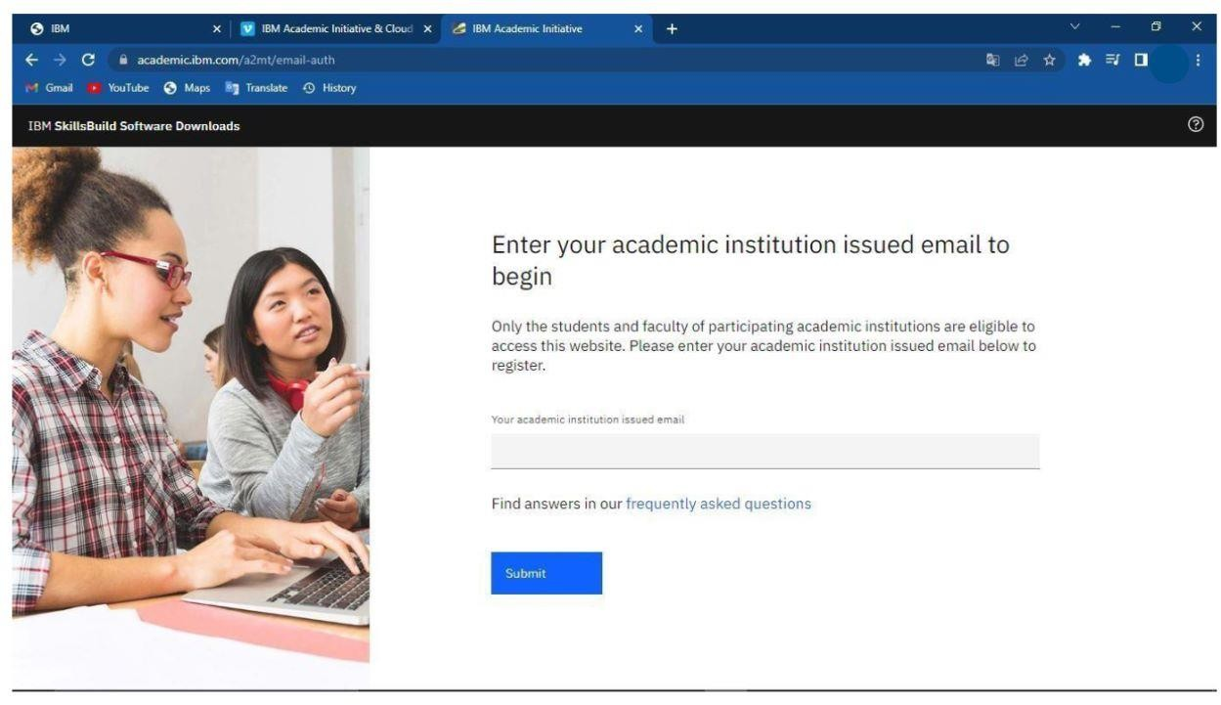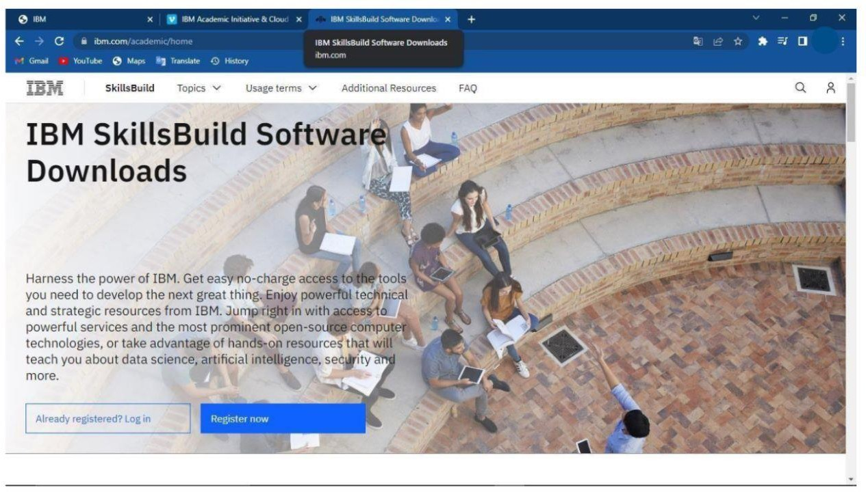

**Step 2: Open Student Profile**

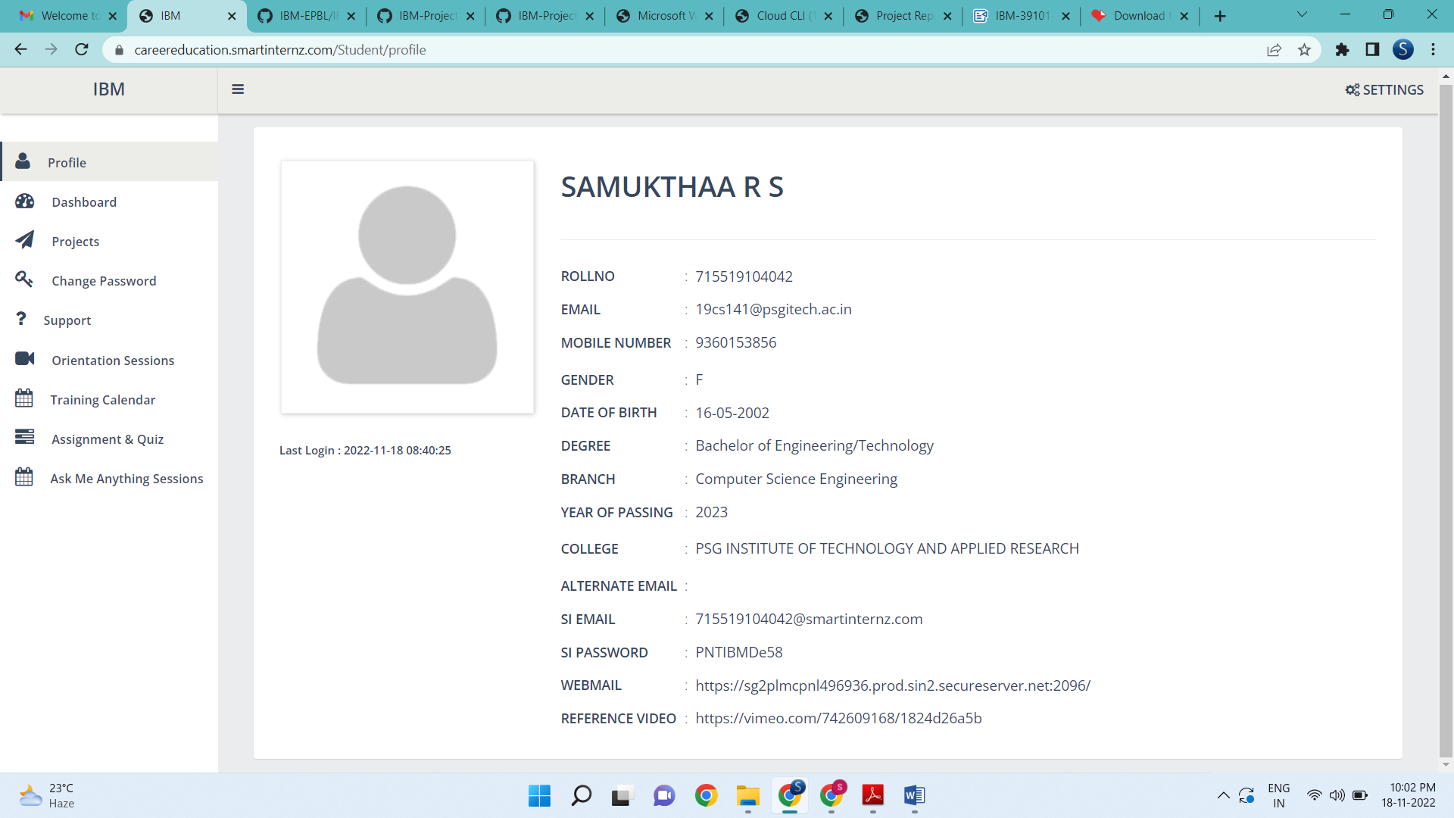

Step 3: Copy SI Email and SI password Login to the IBM Cloud Account

